Descriptive Statistics

Practical 1

-Shrisai Halankar

Source Code:

X <- c(1,2,3,2,4,2,5,4,6,7,8,9)

freq <- data.frame(table(x))

relFreq <- data.frame(prop.table(table(x)))

relFreq$Realtive_Freq <- relFreq$Freq

relFreq$Freq<- NULL

Cumulative_Freq <- cumsum(table(x))

z <- cbind(merge(freq, relFreq),Cumulative_Freq)

z$Cumulative_Relative_Freq <- z$Cumulative_Freq / sum(z$Freq)

print(z)

Output:

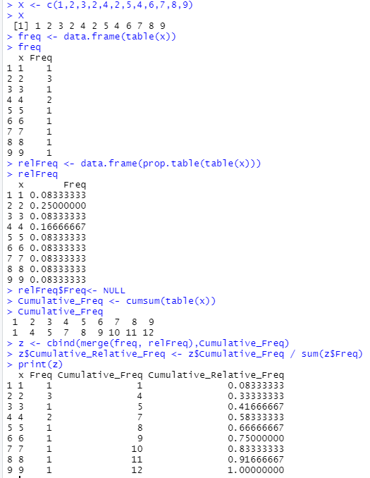

Source Code:

head(faithful)

duration = faithful$eruptions

hist(duration,right=FALSE)

colors = c("red", "yellow", "green", "violet", "orange", "blue", "pink", "cyan")

hist(duration,right=FALSE, col=colors,main="Old Faithful Eruptions")

head(z)

abc = z$Cumulative_Relative_Freq

hist(abc,right=FALSE)

colors = c("red","yellow","green","violet","orange","blue","pink","cyan")

hist(abc,right=FALSE, col=colors,main="frequency")

Output:

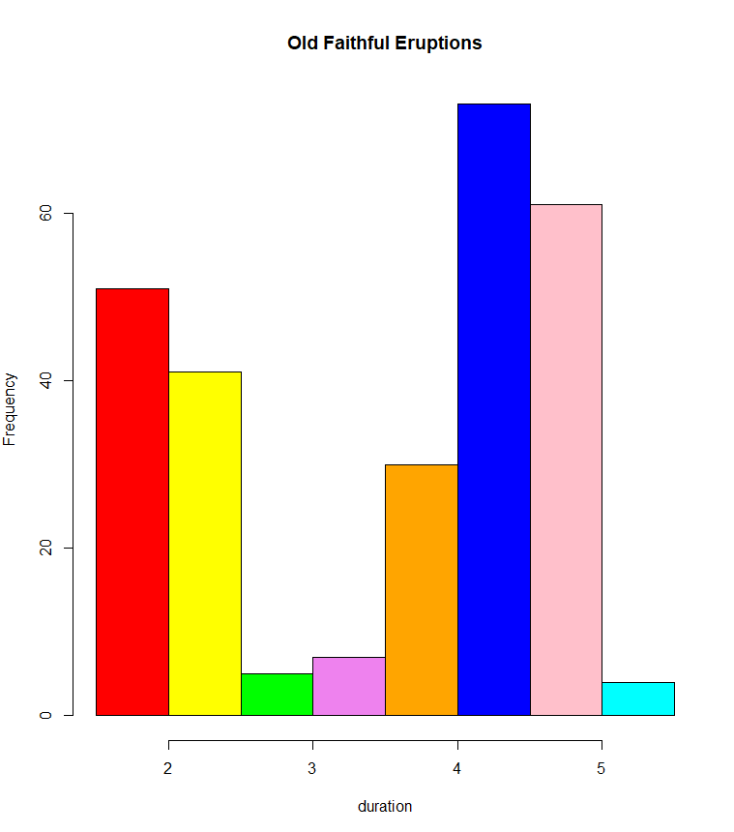

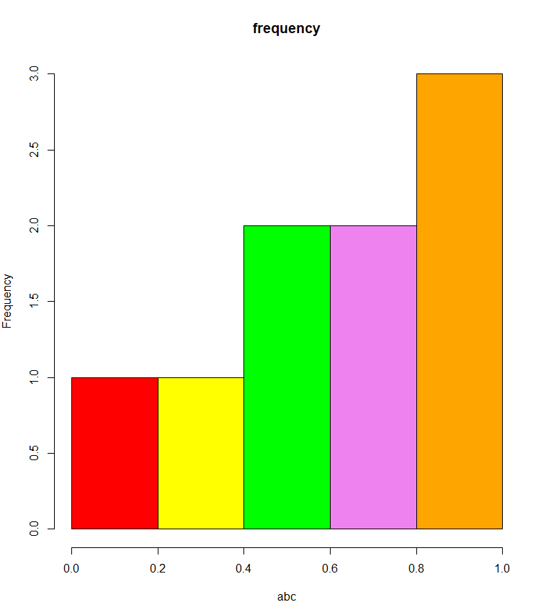

Example 1

A traffic inspector has counted the number of automobiles passing a certain point in 100 successive 20 minutes time period.

Source Code:

X <- c(23,20,16,18,30,22,26,15,5,18,14,17,11,37,21,6,10,20,22,25,19,19,19,20,12,23,24,

17,18,16,27,16,28,26,15,29,19,35,20,17,12,30,21,22,20,15,18,16,23,24,15,24,28,19,

24,22,17,19,8,18,17,18,23,21,25,19,20,22,21,21,16,20,19,11,23,17,23,13,17,26,26,

14,15,16,27,18,21,24,33,20,21,27,18,22,17,20,14,21,22,19)

freq <- data.frame(table(X))

relFreq <- data.frame(prop.table(table(X)))

relFreq$Realtive_Freq <- relFreq$Freq

relFreq$Freq<- NULL

Cumulative_Freq <- cumsum(table(X))

z <- cbind(merge(freq, relFreq),Cumulative_Freq)

z$Cumulative_Relative_Freq <- z$Cumulative_Freq / sum(z$Freq)

print(z)

Output:

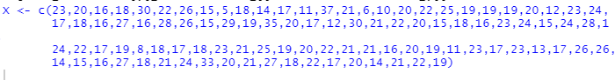

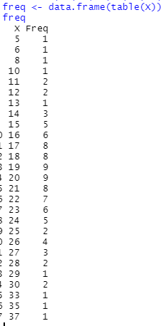

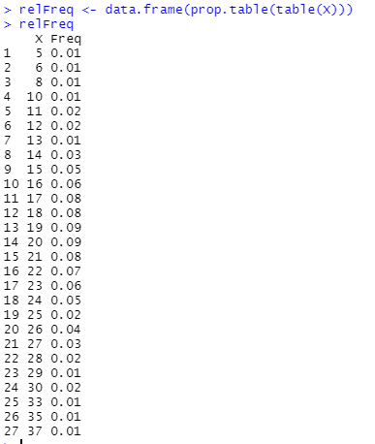

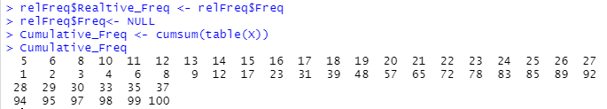

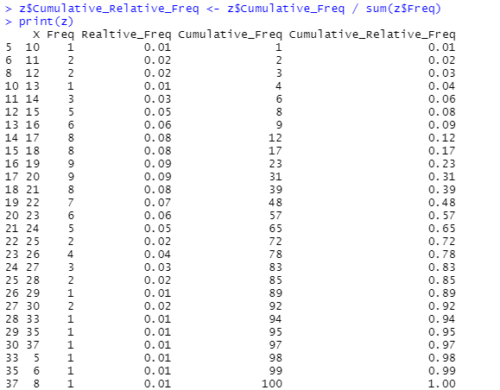

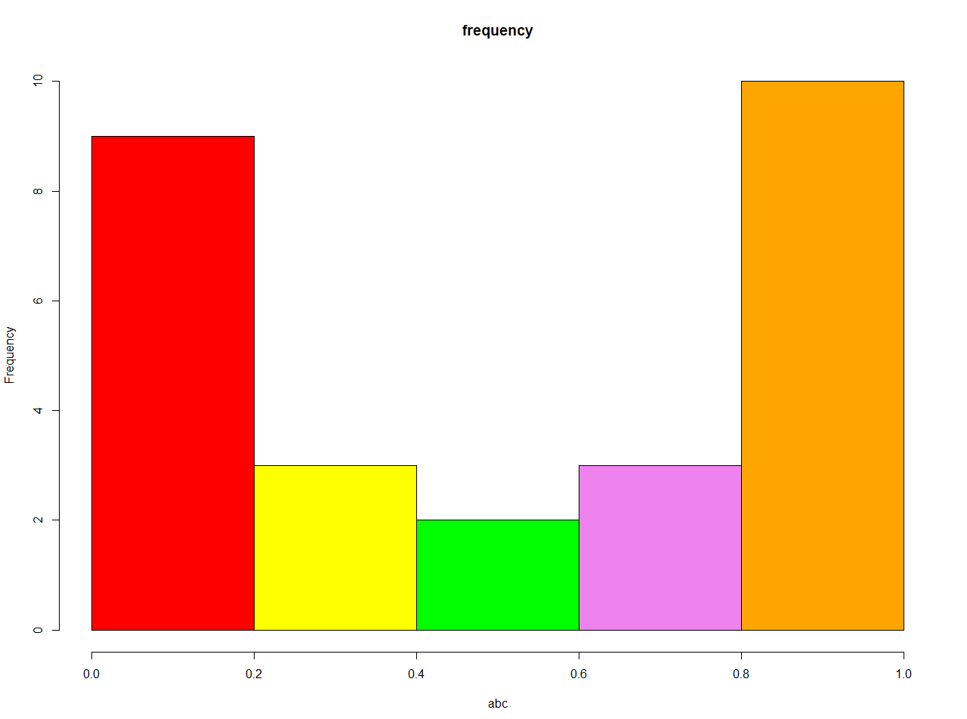

Source Code:

X <- c(13.8,14.1,14.7,15.2,15.6,14.9,16.7,19.2,14.9,14.9,14.9,15.2,15.9,15.2,14.8,14.8,19.1,14.6,18.0,17.2,17.2,14.1,14.5,18.0,14.4,14.2,14.6,14.2,14.8)

freq <- data.frame(table(X))

relFreq <- data.frame(prop.table(table(X)))

relFreq$Realtive_Freq <- relFreq$Freq

relFreq$Freq<- NULL

Cumulative_Freq <- cumsum(table(X))

z <- cbind(merge(freq, relFreq),Cumulative_Freq)

z$Cumulative_Relative_Freq <- z$Cumulative_Freq / sum(z$Freq)

print(z)

head(z)

abc = z$Cumulative_Relative_Freq

hist(abc,right=FALSE)

colors = c("red","yellow","green","violet","orange","blue","pink","cyan")

hist(abc,right=FALSE, col=colors,main="frequency")

Output:

